# Does ethnic density influence community participation in local running events?: a case of parkrun

*Smith R1,Schneider PP1, Bullas A2, Bayley T1, Haake SSJ2, Brennan A1, Goyder E1*

*1School of Health and Related Research, University of Sheffield*  
*2Sheffield Hallam University Advanced Wellbeing Centre*

**Keywords**: parkrun, Participation, Physical Activity, Equity, Ethnic density.

**Intended Journal**: Journal of Racial & Ethnic Health Disparities, Sports Medicine Open,Behavioural and Social Sciences, Journal Of Epi & Comm Health.

### Thumbnail Sketch

#### What is already known on this subject?

parkrun organise weekly 5km running events at parks across the world.Recent research has shown that despite equitable geographical access to parkrun events in England, participation is much lower in more deprived areas.

#### What this study adds?

This study uses regression modelling techniques to better understand the relative influence of geographical access, deprivation and ethnic density on parkrun participation rates in local communities. It finds that areas with higher ethnic density tend to have lower participation rates when controlling for confounding factors.

#### Policy implications

Identifying why particular communities are less likely to engage in parkrun, and finding ways to improve participation from these commmunities is likely to both improve overall population health and reduce inequalities.

# Abstract

parkrun has been very successful in encouraging people in England to participate in their weekly 5km running events. However, there is substantial heterogeneity in parkrun participation across different communities in England: after controlling for travel distances, deprived communities have significantly lower participation rates (Schneider et al. 2019).

This paper aims to expand on previous findings by investigating ethnic disparities in parkrun participation. We combined geo-spatial data, provided by parkrun and available through the ONS, and fitted multivariable Poisson regression models to study the effect of ethnic minorities on participation rates at the aggregate census area level.

We find that areas with a higher proportion of ethnic minorities had lower participation rates. This effect is independent of areas with high deprivation and a high proportion of ethnic minorities have the lowest participation rates. An opportunity exists for parkrun to engage with these communities and reduce potential barriers to participation.

# Introduction

parkrun is a collection of free mass participation 5km running events that take place every Saturday morning. There are currently over 500 locations in England, with a combined weekly attendance of over 100,000. parkrun has been identified as being successful at engaging with individuals who may not otherwise have taken part in organised physical activity [Haake, 2018](http://shura.shu.ac.uk/24200/1/Haake_%20parkrun_a_new_model%28VoR%29.pdf) ; [Stevinson et al. 2013](https://academic.oup.com/jpubhealth/article/36/2/268/1548895), and there is some evidence that it has increased overall physical activity levels in participants [Stevinson et al. 2019](https://academic.oup.com/jpubhealth/advance-article/doi/10.1093/pubmed/fdy178/5123524). Overall, there is a consensus that parkrun has huge public health potential [Reece et al. 2019](https://bjsm.bmj.com/content/bjsports/53/6/326.full.pdf?casa_token=YEz1sYUvjksAAAAA:SABmbZd7t_qrEFEoWSWQkPZt3BCSLaBswWiFguQaSdXEEj_QI2IyBhDroWsScjq1EGiHHEvWbjc).

However, research from Sheffield [Goyder et al. 2018] and more broadly the United Kingdom [Fullagar et al. 2019](https://www.researchgate.net/profile/Simone_Fullagar/publication/336717033_Fullagar_S_Petris_S_Sargent_J_Allen_S_Akhtar_M_Ozakinci_G_in_press_2019_Action_research_with_parkrun_UK_volunteer_organisers_to_develop_inclusive_strategies_Health_Promotion_International/links/5db23b0c4585155e27f966d2/Fullagar-S-Petris-S-Sargent-J-Allen-S-Akhtar-M-Ozakinci-G-in-press-2019-Action-research-with-parkrun-UK-volunteer-organisers-to-develop-inclusive-strategies-Health-Promotion-International.pdf) identified that parkruns located in more deprived areas have lower attendances, and that ethnic diversity was limited. This leads to concern that as with many public health interventions, parkrun is “likely to be responsible for significant intervention generated inequalities in uptake of opportunities for physically active recreation.” [Goyder et al. 2018](https://jech.bmj.com/content/jech/72/Suppl_1/A61.2.full.pdf).

Understanding the determinants of participation in parkrun is therefore an important avenue of future research. A study from Australia using survey data from parkrun participants attempted to do this [Cleland et al., 2019](https://journals.sagepub.com/doi/pdf/10.1177/0890117118770106?casa_token=WIfzcbwmyFoAAAAA:v2iYFcITA7-__9Xn3pZvS9GRw-aIvKkDGLU1bU6__behSpsm__LwcvkTGclu79R42FECROneYL5N). However, due to the biases associated with surveying only parkrun participants the findings have no external validity (i.e. estimating the relationship between education and number of runs once engaged with parkrun does not tell us about the determinants of initial engagement with parkrun). The authors themselves note the limitation that “The sample was limited to a non-random sample of parkrun participants in one State of Australia and may not be generalizable to other parkrun populations.” (p.21).

In attempt to locate the optimal parks in which to locate the next 200 parkrun events, our previous work has revealed that there is substantial heterogeneity in parkrun participation across different communities in England. After controlling for travel distances, deprived communities have significantly lower participation rates (Schneider et al. 2019). This analysis was able to quantify, for the first time, how participation in parkrun varied in different communities in England. However, the analysis was interested only in the relationship between participation, access and deprivation and did not consider other potential determinants of participation in parkrun. This paper extends this part of our previous analysis to better understand how access, deprivation, ethnicity, population density and age of the community influence parkrun participation in England.

Our initial hypothesis was that areas with a higher proportion of ethnic minority residents have lower participation in parkrun. We thought this because; 1) there is strong evidence from survey data that ethnic minority individuals in England are less likely to be physcially active, and to engage in sport in general [Sport England](https://www.sportengland.org/media/3513/sports-participation-and-ethnicity-in-england-headline-findings.pdf), and 2) previous research has identified low levels of ethnic minority participation in parkrun [Goyder et al. 2018](https://jech.bmj.com/content/jech/72/Suppl_1/A61.2.full.pdf) [Fullagar et al. 2019](https://www.researchgate.net/profile/Simone_Fullagar/publication/336717033_Fullagar_S_Petris_S_Sargent_J_Allen_S_Akhtar_M_Ozakinci_G_in_press_2019_Action_research_with_parkrun_UK_volunteer_organisers_to_develop_inclusive_strategies_Health_Promotion_International/links/5db23b0c4585155e27f966d2/Fullagar-S-Petris-S-Sargent-J-Allen-S-Akhtar-M-Ozakinci-G-in-press-2019-Action-research-with-parkrun-UK-volunteer-organisers-to-develop-inclusive-strategies-Health-Promotion-International.pdf).

# Methods

Data was obtained from multiple sources at the Lower layer Super Output Level (LSOA), which are geographical areas containing around 1,000-3,000 people. There are 32844 LSOAs in England. [parkrunUK](https://www.parkrun.org.uk/) provided data on the number of runs from each LSOA in England between the 1st January and 10th December 2018. The ethnic breakdown of each LSOA was obtained from the Office of National Statistics (ONS) [here](https://www.ons.gov.uk/peoplepopulationandcommunity/populationandmigration/populationestimates/datasets/lowersuperoutputareamidyearpopulationestimates). The deprivation scores and population sizes for each LSOA was obtained from the ONS. More information can be found [here](https://assets.publishing.service.gov.uk/government/uploads/system/uploads/attachment_data/file/835115/IoD2019_Statistical_Release.pdf). The population density for each LSOA was obtained from the ONS [here](https://www.ons.gov.uk/peoplepopulationandcommunity/populationandmigration/populationestimates/datasets/lowersuperoutputareapopulationdensity). The geographic weighted centroids for each LSOA were obtained from the ONS [here](http://census.ukdataservice.ac.uk/get-data/boundary-data.aspx). The location of each parkrun event was obtained from the parkrunUK website [here](https://www.parkrun.org.uk/).

|  |  |  |
| --- | --- | --- |
| Variable | Description | Source |
| run_count | number of runs from each LSOA in England between 1st January and 10th December 2018 | parkrunUK |
| imd | IMD scores for each LSOA | <https://assets.publishing.service.gov.uk/government/uploads/system/uploads/attachment_data/file/835115/IoD2019_Statistical_Release.pdf> |
| total_pop | total number of individuals in each LSOA | <https://assets.publishing.service.gov.uk/government/uploads/system/uploads/attachment_data/file/835115/IoD2019_Statistical_Release.pdf> |
| pop_density | population density for each LSOA | <https://www.ons.gov.uk/peoplepopulationandcommunity/populationandmigration/populationestimates/datasets/lowersuperoutputareapopulationdensity> |
| perc_bme | Ethnic Density: percent of population non-white-british | <https://www.ons.gov.uk/peoplepopulationandcommunity/populationandmigration/populationestimates/datasets/lowersuperoutputareamidyearpopulationestimates> |
| mn_dstn | distance from LSOA centroid to nearest parkrun | derived |
| perc_non_working_age | derived from ONS data on age-groups in each LSOA | derived |
| run_rate | derived from run_count and LSAO populations | derived |

After merging these datasets we had detailed data on 32844 LSOAs participation in parkrun and several characteristics of the LSOAs which we hypothesised may influence participation. Since previous work has found correlations between participation and deprivation, distance to nearest event, and population density we included all of these variables. We also extended the analysis to include the percent of the population of black and ethnic minority (BME) (our simple proxy for ethnic density) and the percent of the population who are working age. We are interested in ethnic density as we hypothesised that areas with higher ethnic density would have lower participation rates. We included the percent of the population that is working age as a control to limit for the effect of populations heavily skewed toward older people (e.g. care homes), or very young people (e.g orphanages/immediately around special needs schools). Since participation in parkrunUK is dominated by those aged 20-60 we felt this was justified.

We used R Software Environment to produce simple summary statistics and viewed simple correlations between the variables described. We then moved on to estimate the partial correlation coefficients between the variables, before running a poisson regression model on scaled data to estimate the relative influence of several determinants on parkrun participation.

# Results

Participation in parkrun varies between LSOAs. Around half of all communities (LSOA) average less than 1 run per week per 1000 people. Approximately a quarter average between 1 and 2 runs, and around an eighth between 2 and 3 runs.

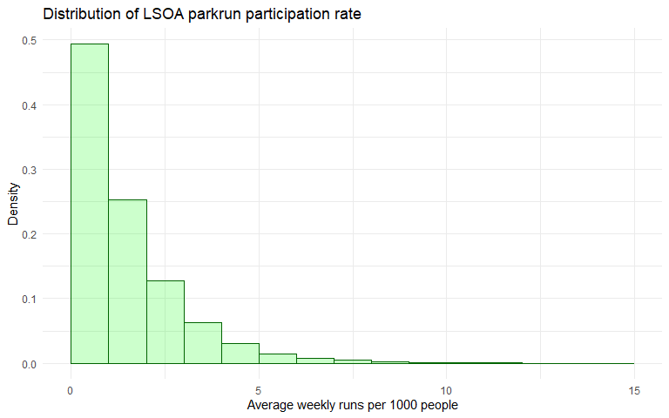

## Correlation Matrix

There is a negative correlation between particpation (run_count) and: deprivation (imd), distance to nearest parkrun (mn_distance), population density (pop_density) and ethnic density (perc_bme). Ethnic density is strongly postively correlated with population density, negatively correlated with percent non-working age, and moderately positvely correlated with IMD suggesting that areas with higher ethnic density are more densely populated overall, more deprived and have fewer older people.

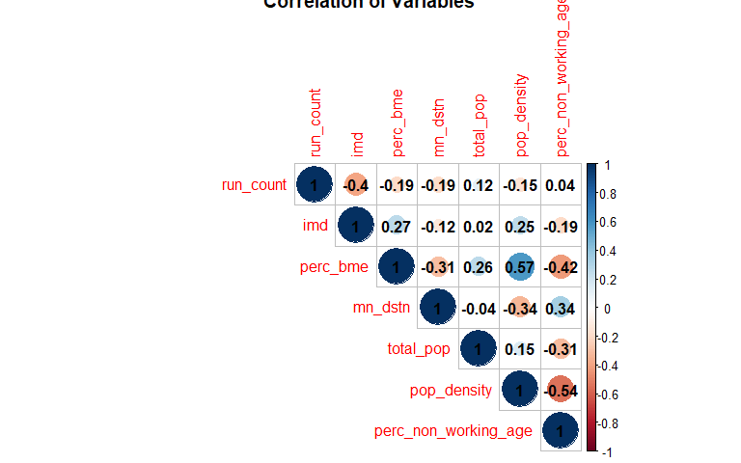

## Colour plot

We are interested in particular in how participation in parkrun varies by ethnic density and IMD of the community. We split our LSOA into deciles based on the two variables and represent the mean participation rate for LSOAs which fall into the repsective deciles (e.g. 2,5 means decile 2 for BME and 5 for IMD) as a colour on the plot.

The plot shows that participation is lowest in areas with the highest deprivation, and that there is a complex relationship between ethnic density and participation, with higher participation in areas with moderately high percentage BME. It is important to note that we do not control for other factors, such as the age of residents or the population density and there are therefore many confounding factors.

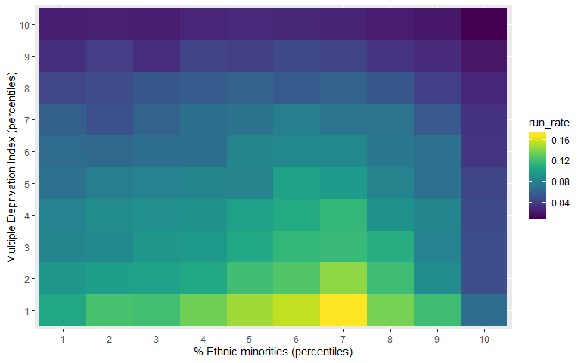

## Partial correlation matrix

In order to control for confounders, we created a partial correlation matrix. This estimates the correlation between the variables in the analysis holding all other variables constant.

Looking at the top row, it is clear that participation rates and deprivation is strongly correlated, but less so now we are controlling for other variables. Distance is also strongly correlated, as was the case in [Schneider et al., 2019]. Ethnic density is also negatively correlated, suggesting that some of the relationship between participation and IMD is attributable to the ethnic density of the area.

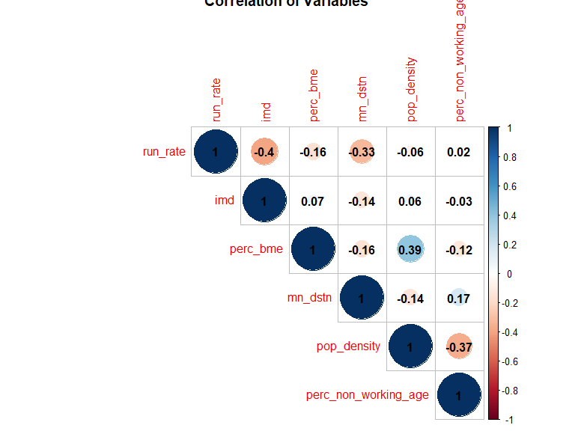

## Poisson Model

Poisson models are commonly used to estimate count data, where values are constrained to be above 0. In this case, because it is not possible for a community to have negative participation we use a Poisson regression.

The results of the poisson regression are not notoriously easy to interpret, but show that areas with a higher ethnic density have lower participation rates, even when controlling for the effect of deprivation and distance to events. The effect is smaller than deprivation and distance, but still sizeable and significant.

% Table created by stargazer v.5.2.2 by Marek Hlavac, Harvard University. E-mail: hlavac at fas.harvard.edu % Date and time: Wed, Nov 13, 2019 - 17:49:17

# Discussion

Previous analysis by [Scheider et al., 2019](https://www.medrxiv.org/content/early/2019/08/29/19004143.full.pdf) has showed that participation in parkrun in England is lower in more deprived communities, and communities that are further from their nearest parkrun. This paper extends that analysis to include other community level characteristics which were hypothesized to influence parkrun participation. Our findings show that some of the negative effect on participation previously attributed to deprivation can actually be attributed to differences in participation by ethnic minorities.

We find that communities with higher ethnic density were less likely to participate in parkrun, even when controlling for deprivation. Since ethnic density and deprivation are positively correlated, it is likely that some of the effect attributed to deprivation in our previous analysis [Scheider et al., 2019](https://www.medrxiv.org/content/early/2019/08/29/19004143.full.pdf) is attributable to ethnicity.

parkrun’s mission states that they aim to increase levels of physical activity in deprived communities. Our findings indicate that participation in deprived communities with ethnic density is particularly low. Further research could be undertaken to ascertain trends in participation from different groups in society, allowing parkrun to monitor the effectiveness of their efforts to reach minority communities. More research is needed to understand the barriers to attending parkrun for members of those communities.

# Limitations

This analysis is ecological and therefore it is not possible to make conclusions at an individual level without making an ecological inference fallacy. We have been careful to make conclusions at the level of the LSOA, rather than te individual level. Nevertheless, given that the evidence at the individual level points to lower participation in organised sport by those from ethnic minority backgrounds (insert REF), we think it is likely that the same effect exists at the individual level.

Our dependent variable is the number of runs by residents of each LSOA. This is a count variable where each run is treated equally (e.g. 10 runs by one person is equal to 1 run by 10 people). We cannot therefore draw inferences on the number of people who took part within each LSOA at some point in the year, but instead focus on the total run count.

We controlled for several variables which we thought would influence participation, it is possible that there are other confounding factors which have not been included.

# Conclusion?

# References